19-1 IGP Interior Gateway Protocol Fundamentals Configuration – Lab Exercise

In this lab you will configure the RIPv2 and EIGRP routing protocols. IP addresses are already configured on the routers.

Lab Topology
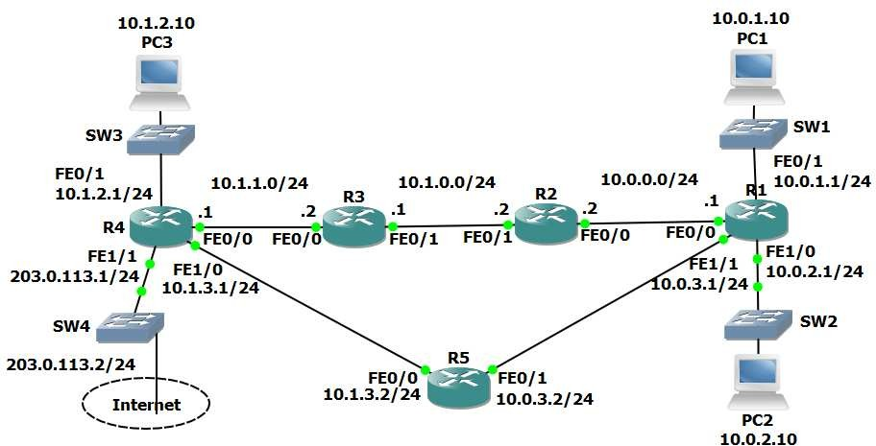

Load the Startup Configurations

Open the ‘19-1 IGP Fundamentals Configuration.pkt’ file in Packet Tracer to load the lab.

RIP Configuration

- Enable RIPv2 on every router. Ensure all networks except 203.0.113.0/24 are advertised. Do not perform any summarisation.

- Verify all networks are in the router’s routing tables.

- Verify that routing is working by checking that PC1 has connectivity to PC3.

- Ensure that all routers have a route to the 203.0.113.0/24 network. Internal routes must not advertised to the Service Provider at 203.0.113.2.

- Verify that all routers have a path to the 203.0.113.0/24 network.

- Configure a default static route on R4 to the Internet via the service provider at 203.0.113.2

- Ensure that all other routers learn via RIP how to reach the Internet.

- Verify all routers have a route to the Internet.

EIGRP Configuration

- Enable EIGRP AS 100 on every router. Ensure all networks except 203.0.113.0/24 are advertised in EIGRP.

- Verify the routers have formed adjacencies with each other.

- Which routing protocol (RIP or EIGRP) do you expect routes to the
10.x.x.x networks to be learned from in the routing tables?

- Do you expect to see any routes from the other routing protocol in the routing tables?

- View the routing tables to verify your answers.

